This project is a simple distance sensor that turns on a light. You will need a distance sensor, 3 resistors, 1 led, and many wires.

First step is following this :https://gpiozero.readthedocs.io/en/stable/recipes.html#distance-sensor
This shows how to wire the distance sensor. If the sensor smells like it's burning, then it's wired wrong. Try switching the 1st and 4th wires on the distance sensor.
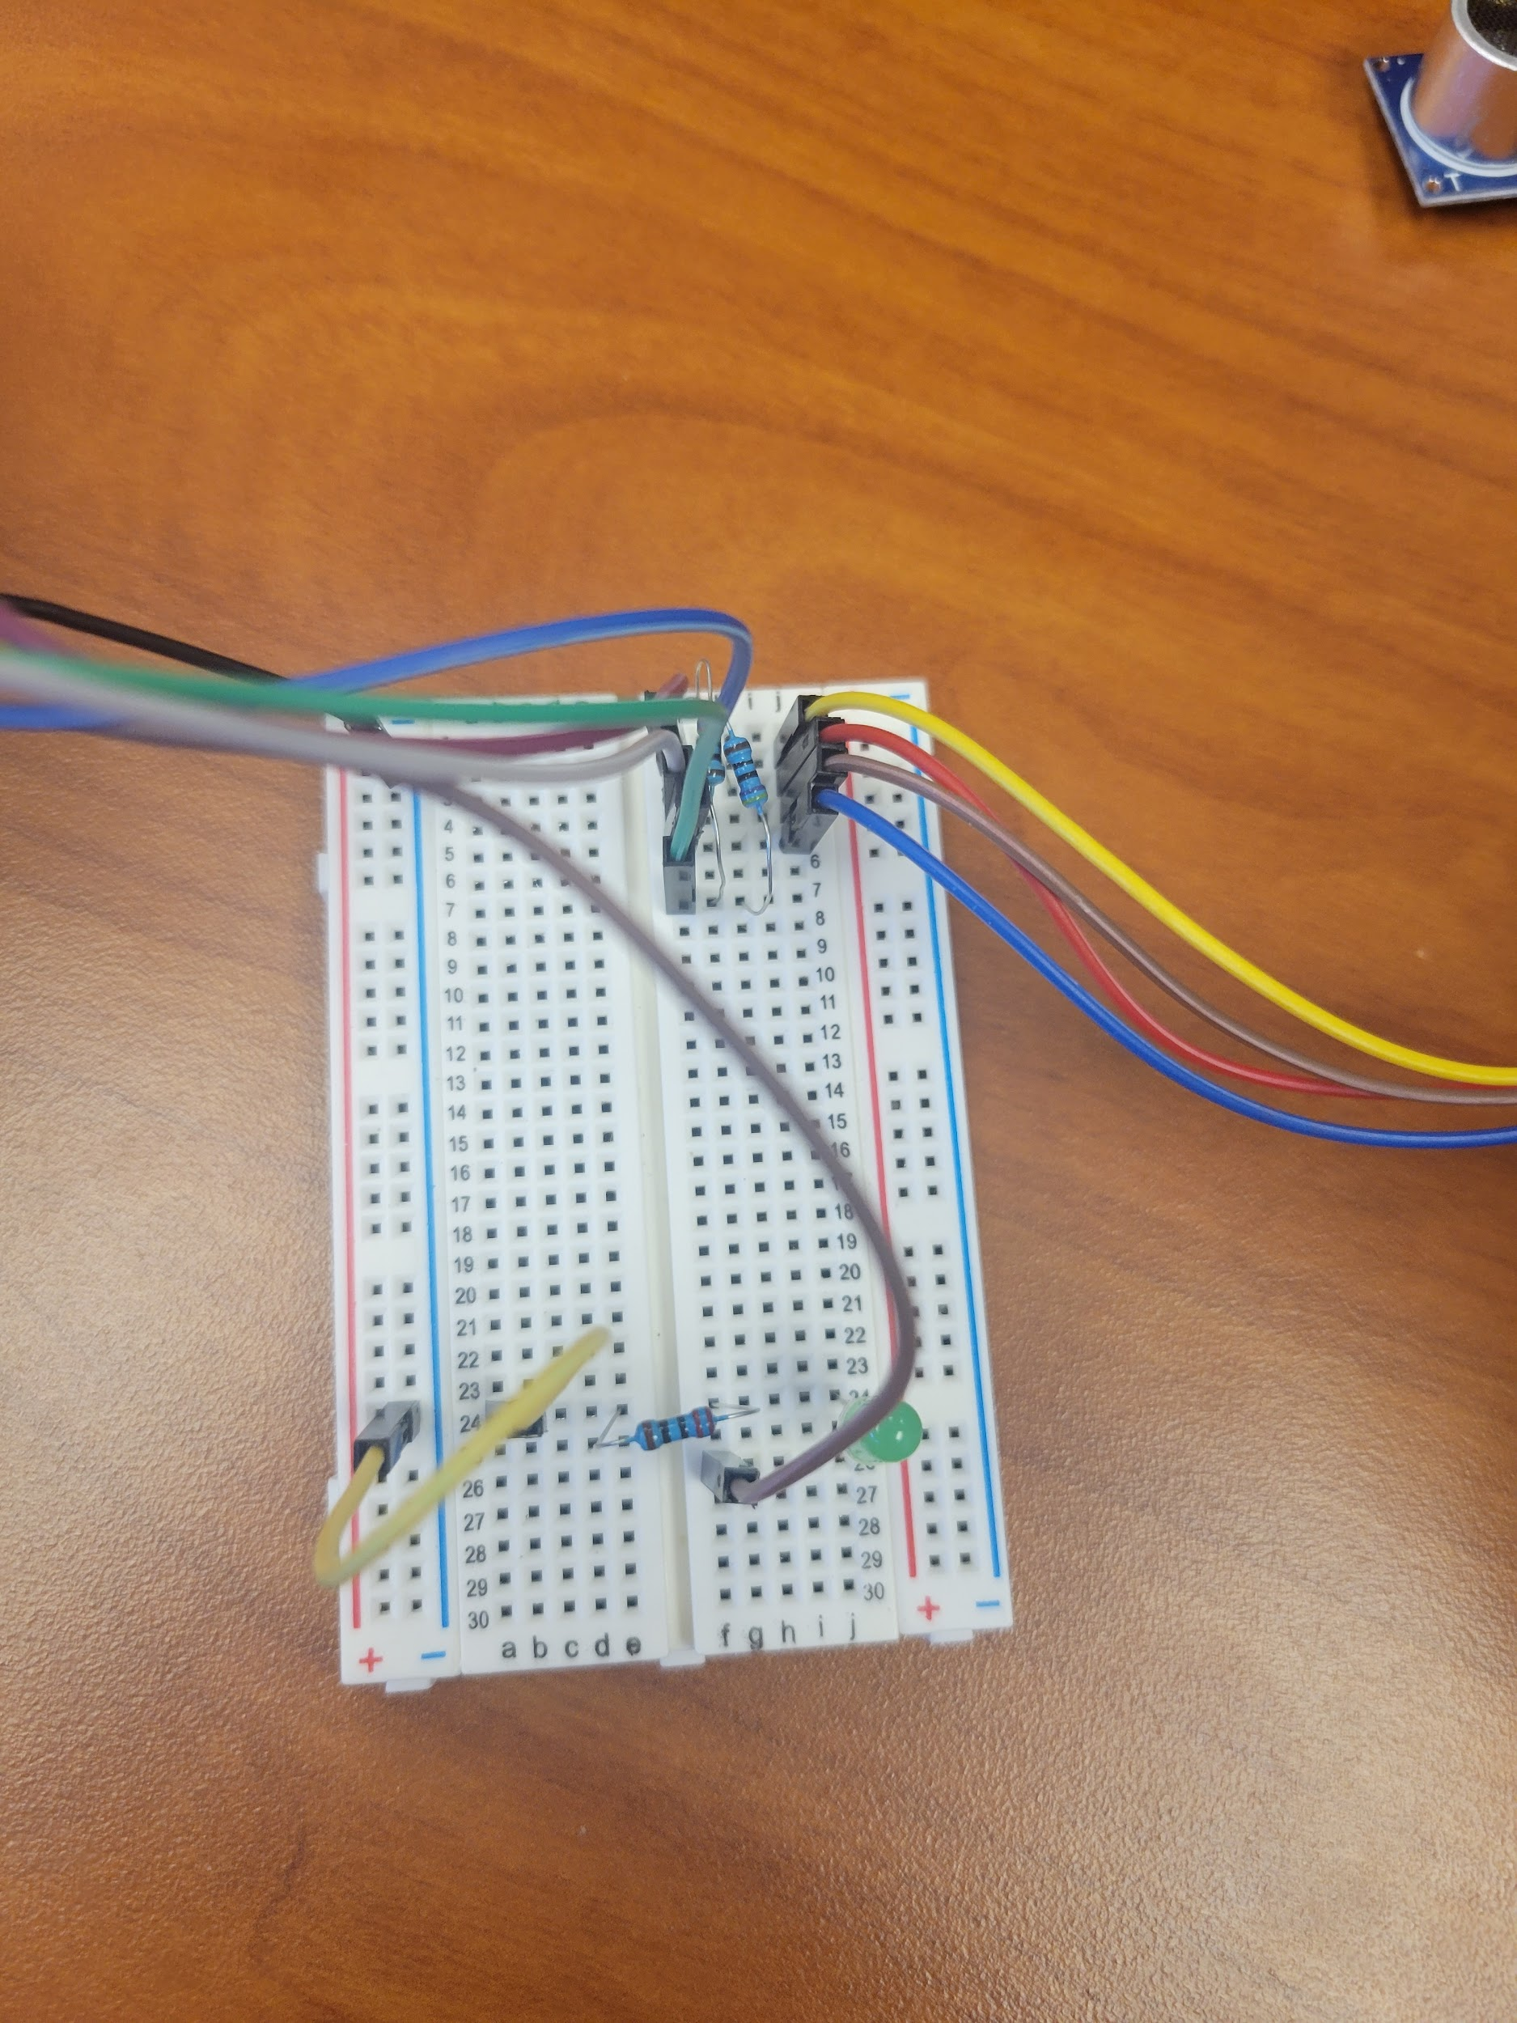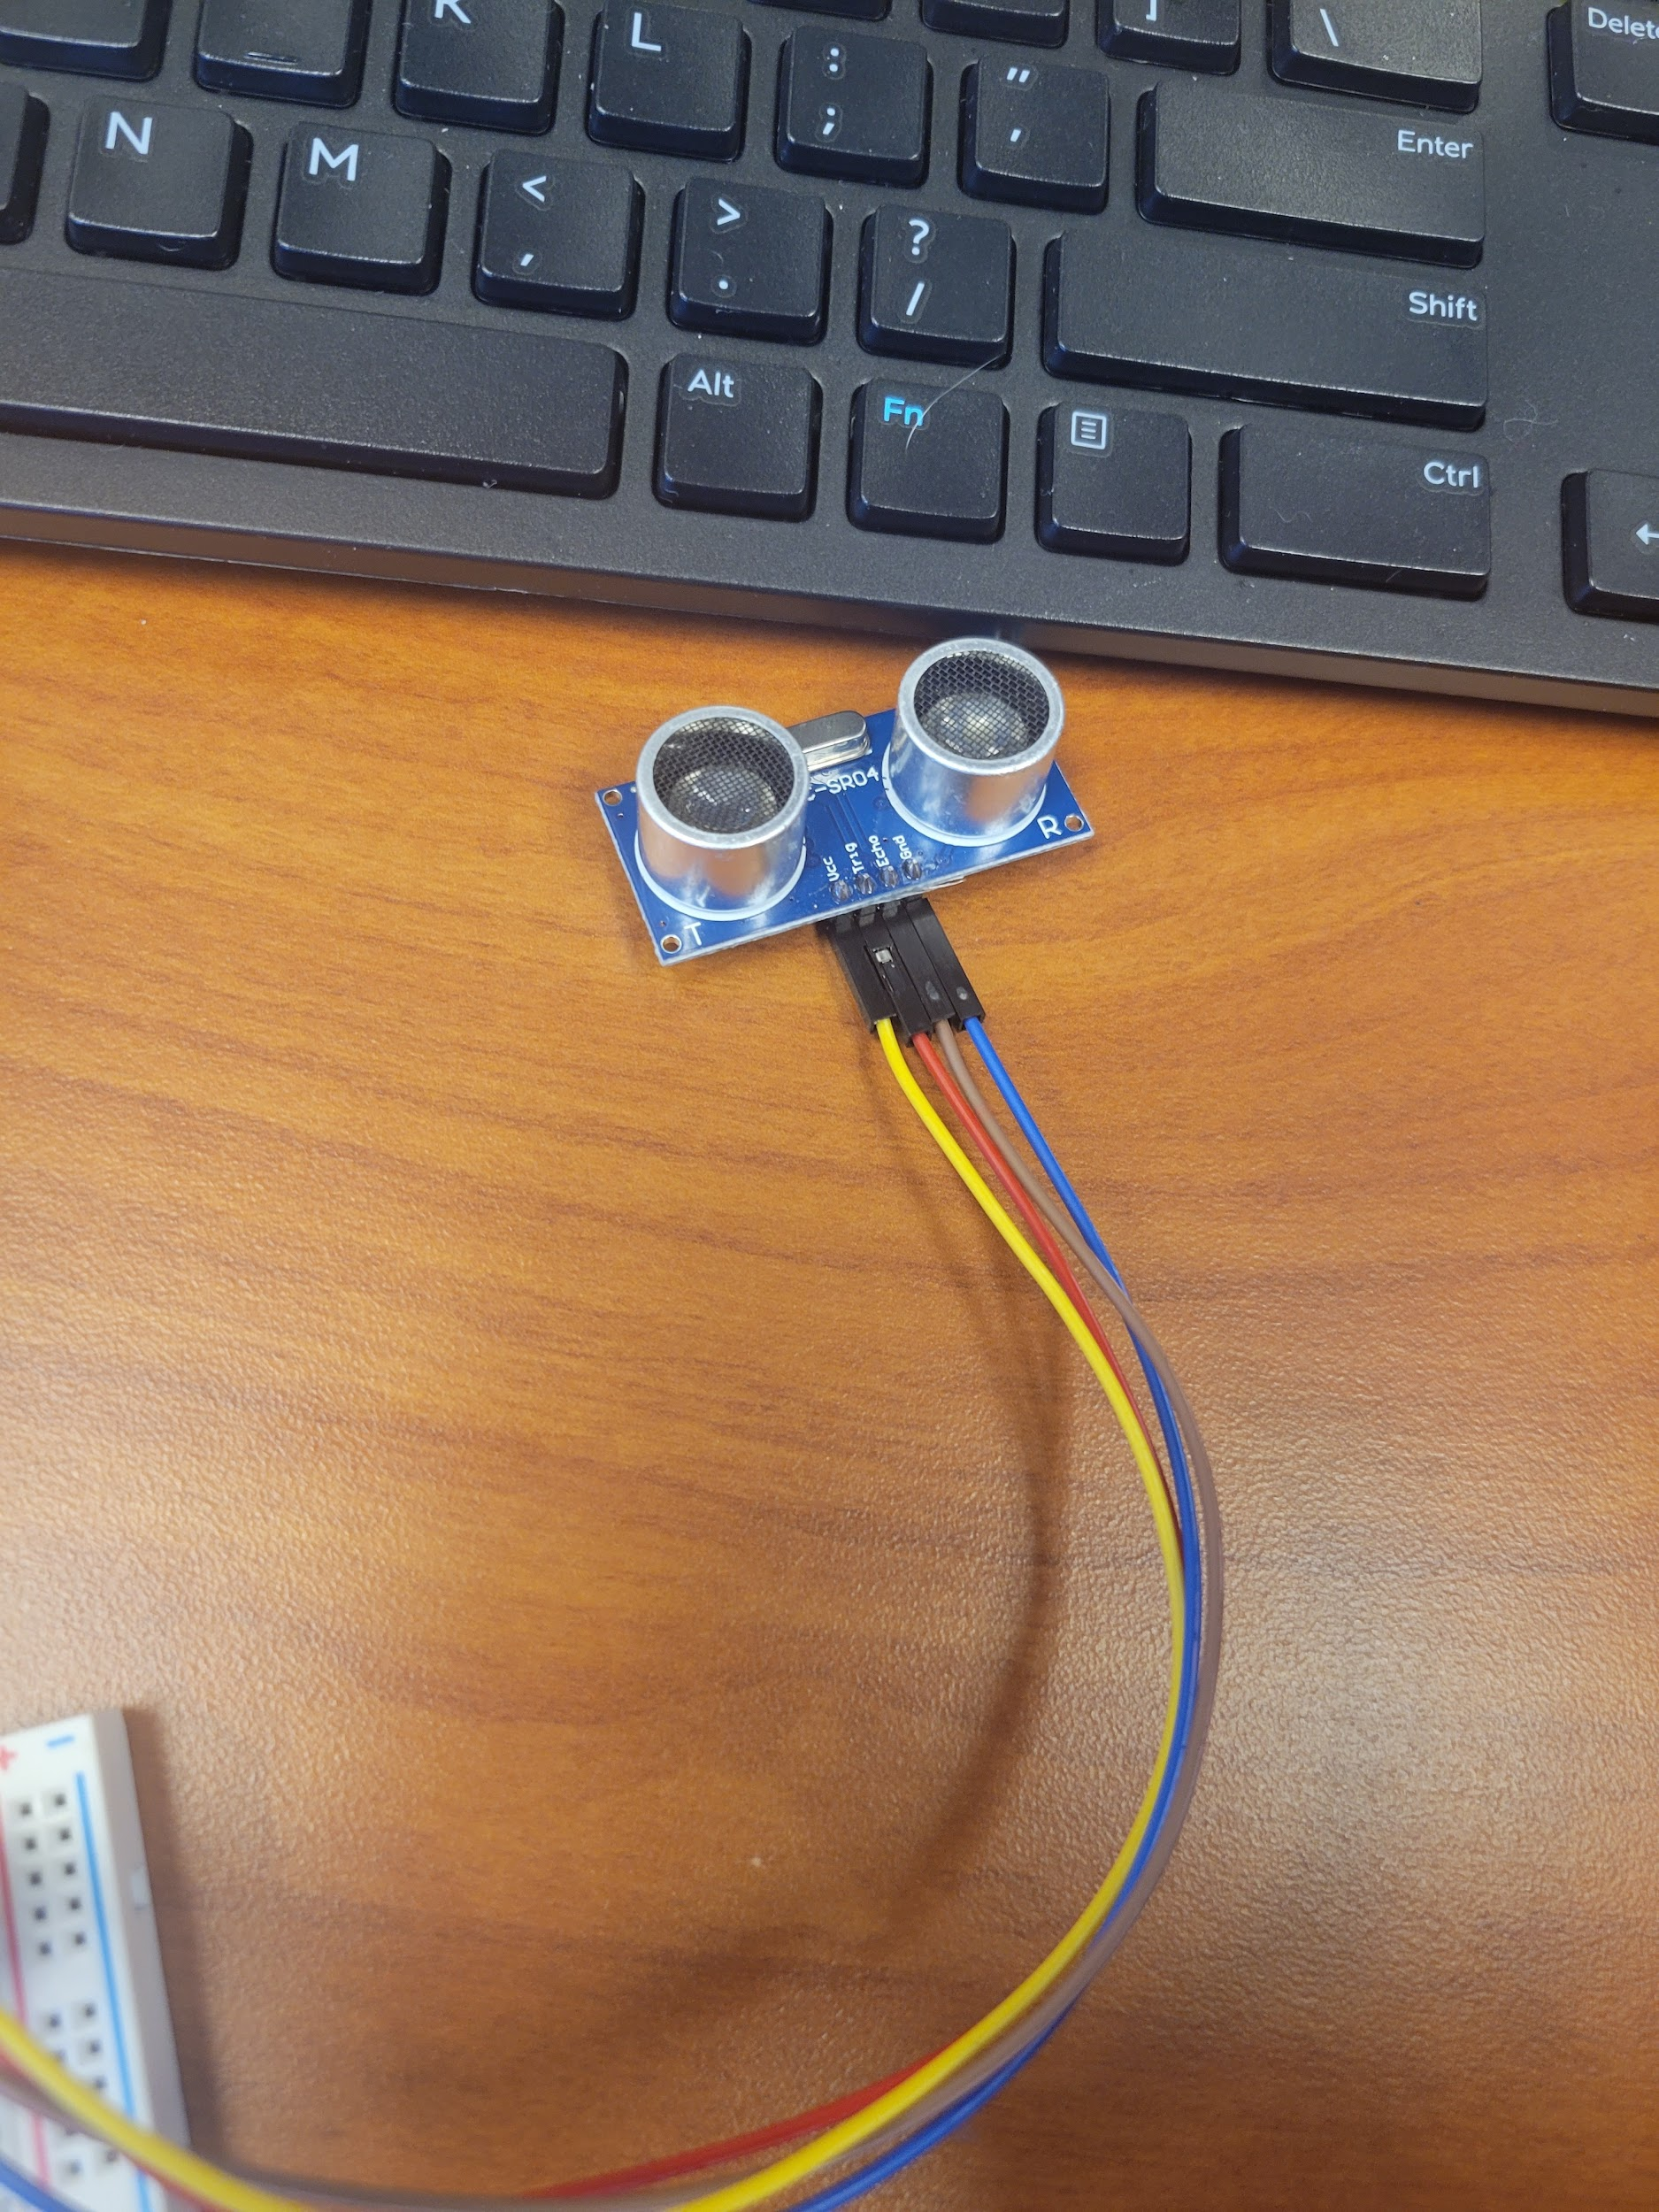
To test if everything is working copy this code.
``from gpiozero import DistanceSensor
from time import sleep

sensor = DistanceSensor(23, 24)

while True:
print('Distance to nearest object is', sensor.distance, 'm')
sleep(1)
``
Typically, i have to switch 23 and 24.

Step two is connecting the led, in the picture you see one wire connected to the pi, the led, a resistor, and a wire to ground on the breadboard, in the picture the led is on the gpio13 pin.
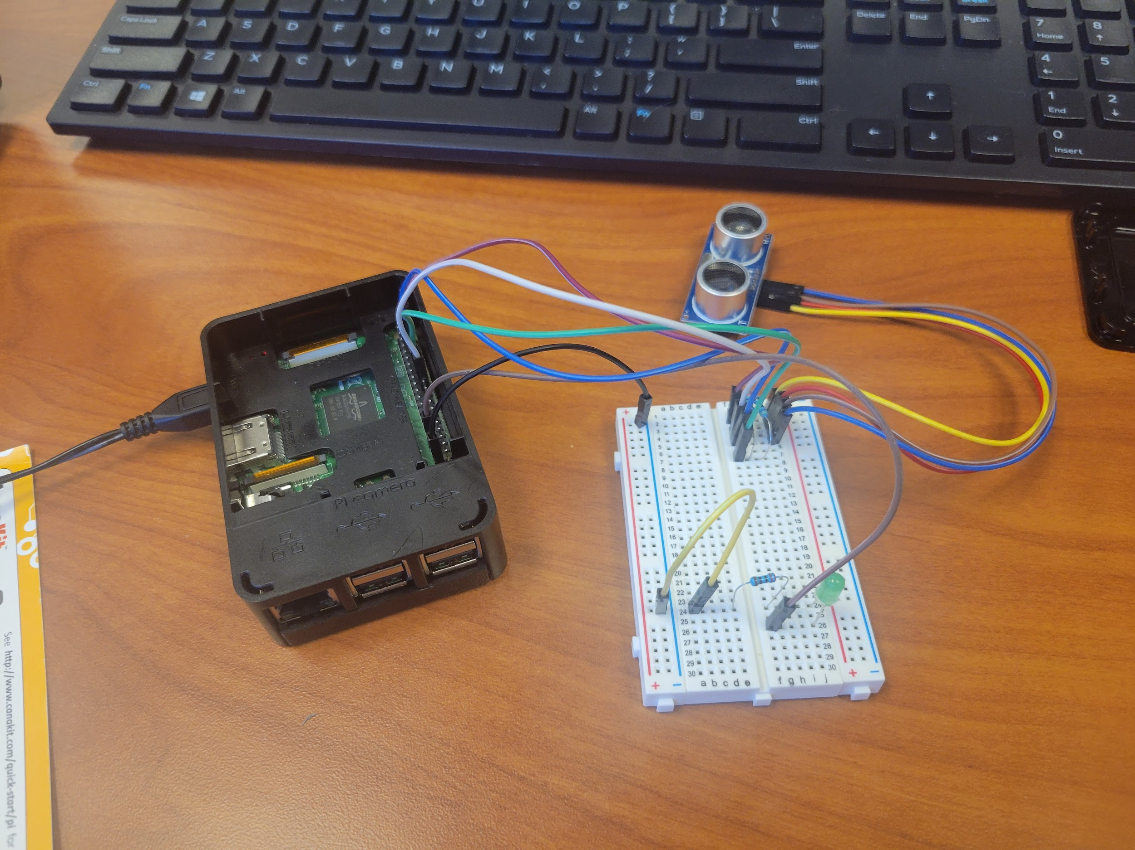
Finally if nothing smells like burning you run the new code
``from gpiozero import DistanceSensor, LED
from time import sleep

sensor = DistanceSensor(24, 23)
led = LED(13)

while True:
print('Distance to nearest object is', sensor.distance, 'm')

if (sensor.distance <= .5):
led.on()
sleep(1)
else:
led.off()
``
The sensor distance can be changed.
This turns on a led when it senses something in range, and turns it off when not in range.

